# Jenkins task for Day-02.

* **Configure 2 slave machines in Jenkins master.**

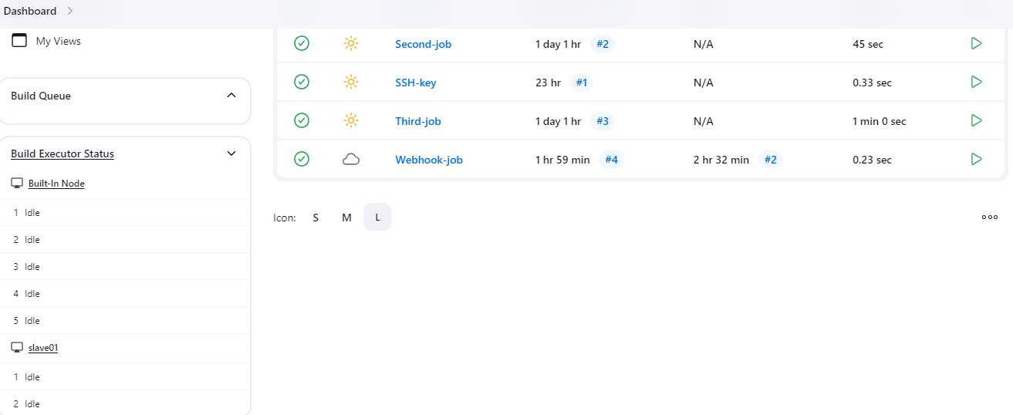

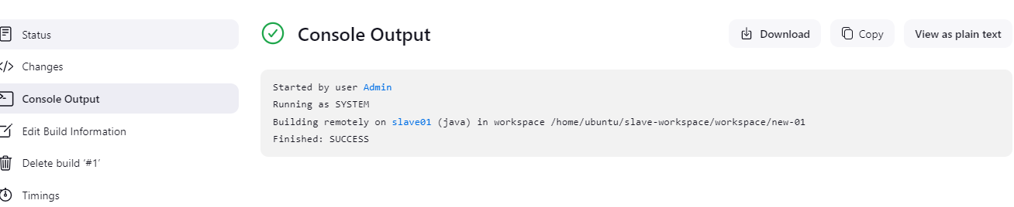

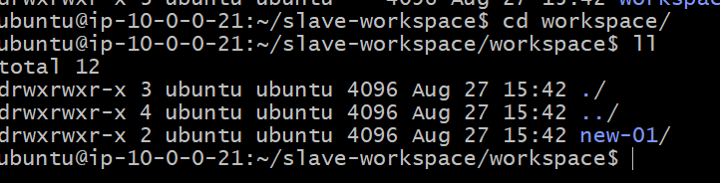

Second slave

* **Configure webhooks to Jenkins job.**

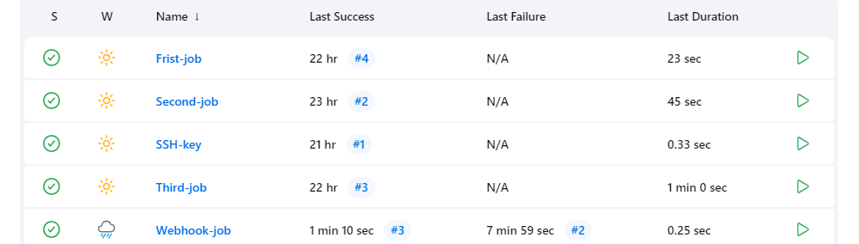

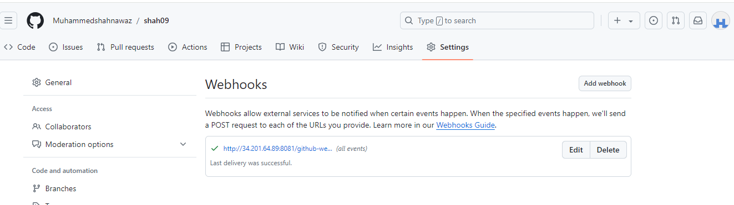

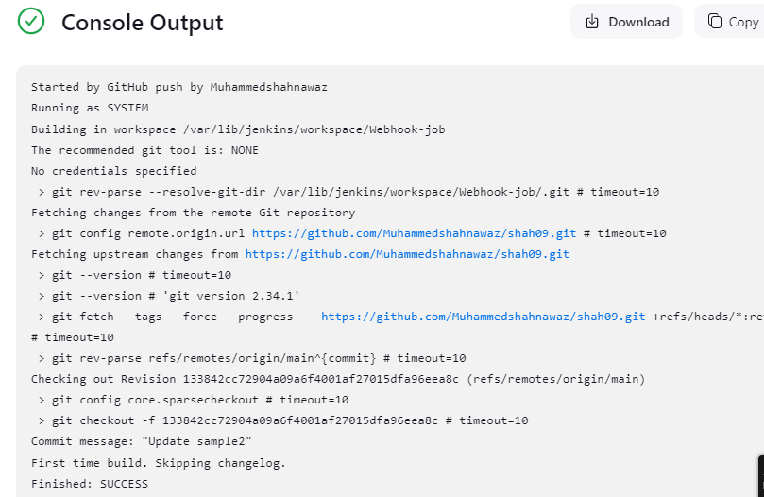

* **Configure poll scm and build periodical options in Jenkins job**.

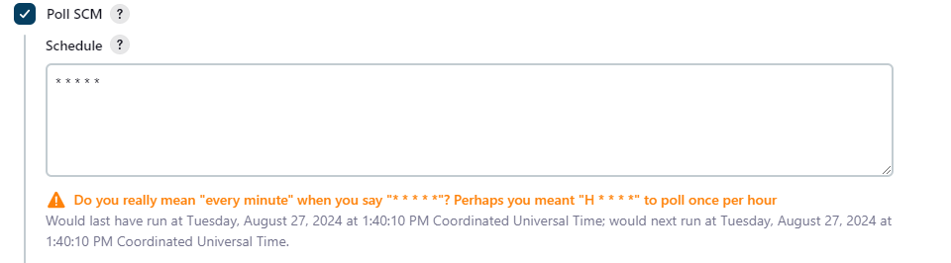

Every 1min will triggered

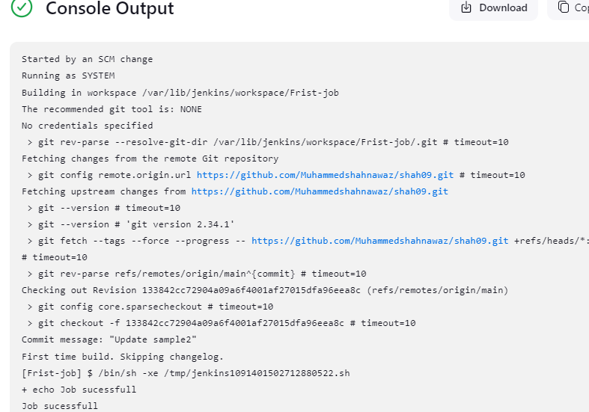

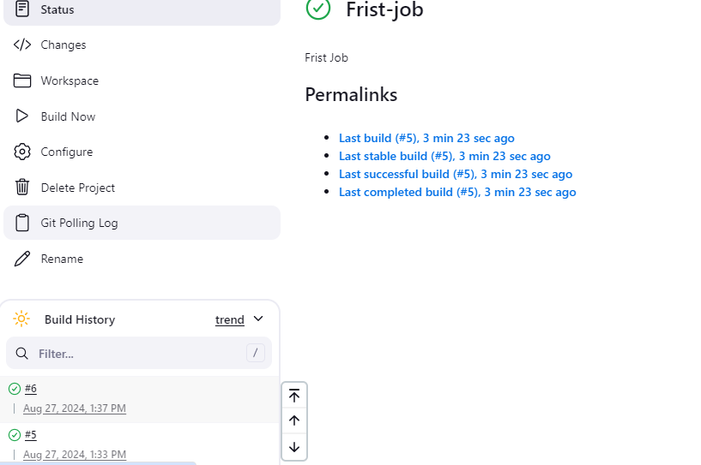

* **Take backup of Jenkins server by using bash script.**
* **Take backup of Jenkins using rethin backup plugin.**
* **Setup a new Jenkins server and dump the backup taken in task4.**